Living Room Furniture:

1. Mavis Grey Wool Sofa:

Super tailored in menswear-inspired dark grey wool, sofa nods to '70s vintage Italian design. Benchmade in Europe and elevated on tall, slim black metal legs. Sofa features a subtle curve on both arms and across the back cushions, displaying fine details from every angle. CB2 exclusive.

DETAILS

* 100% wool in charcoal
* Hardwood frame is benchmade and kiln-dried to prevent warping
* Black metal legs
* Spot-clean only
* Made in Lithuania
* See product label or call customer service for additional details on product content

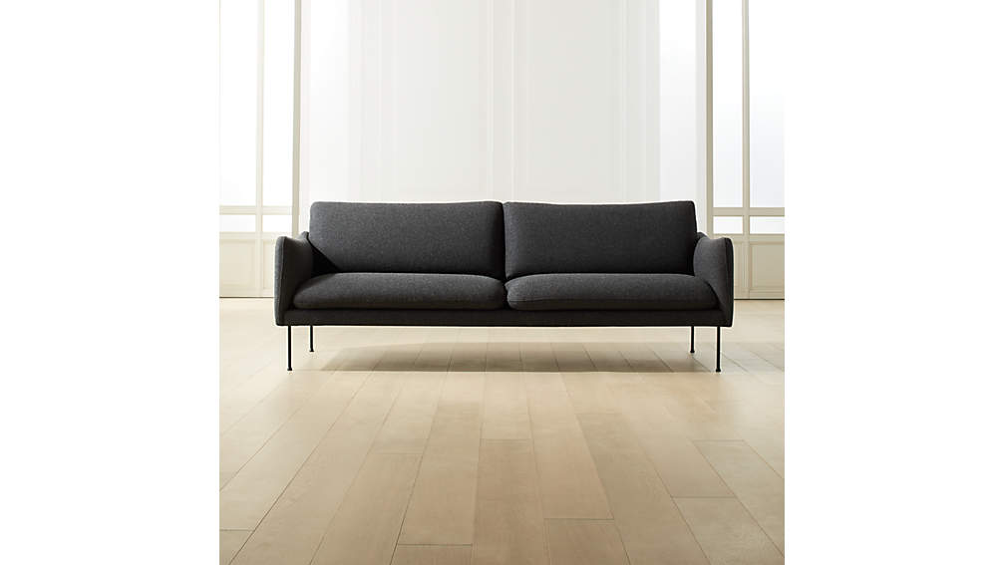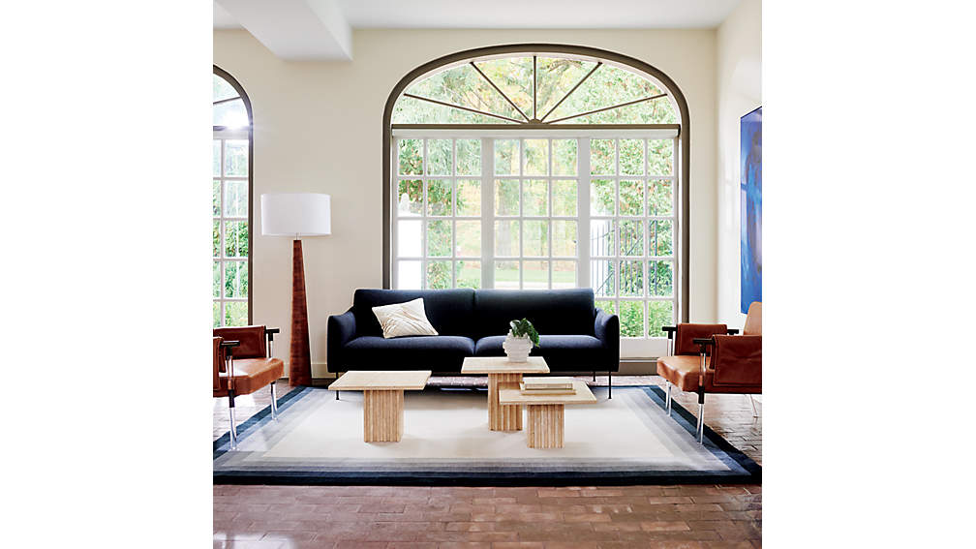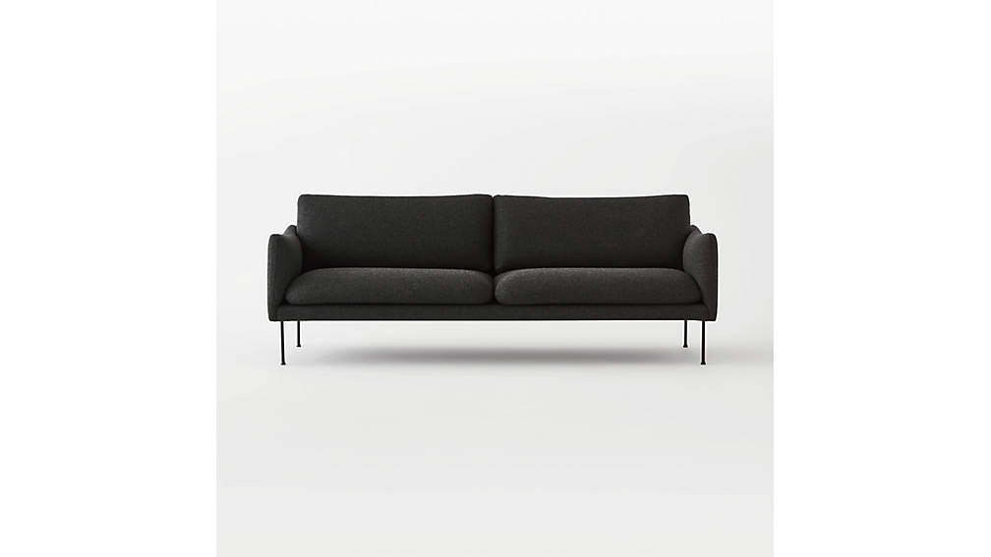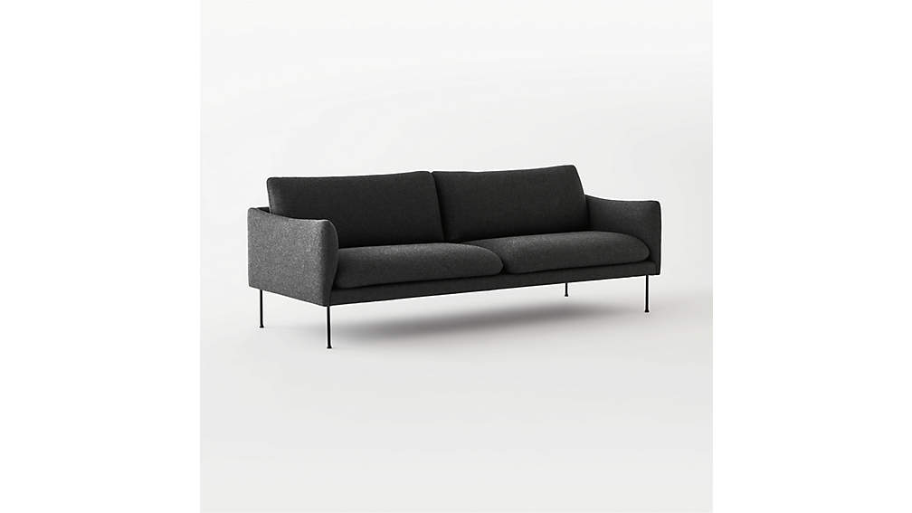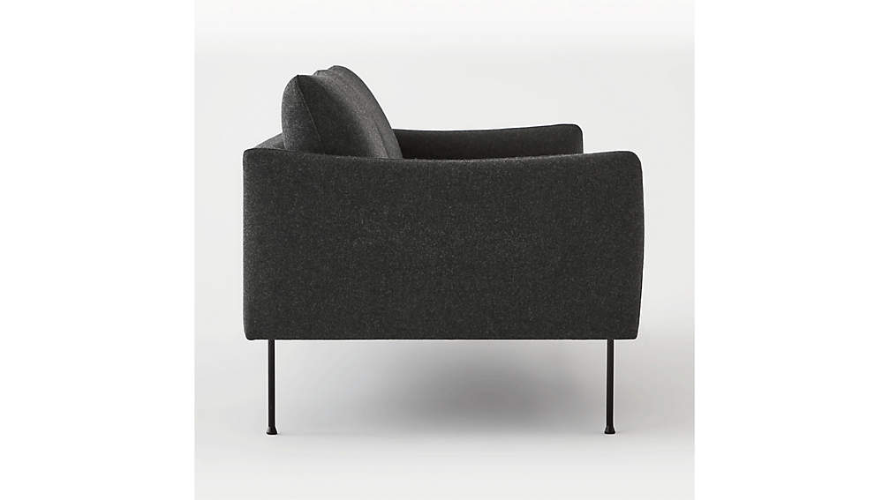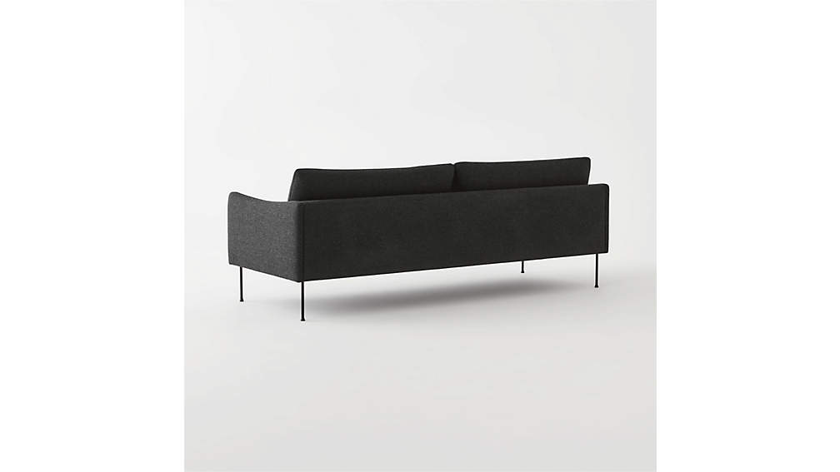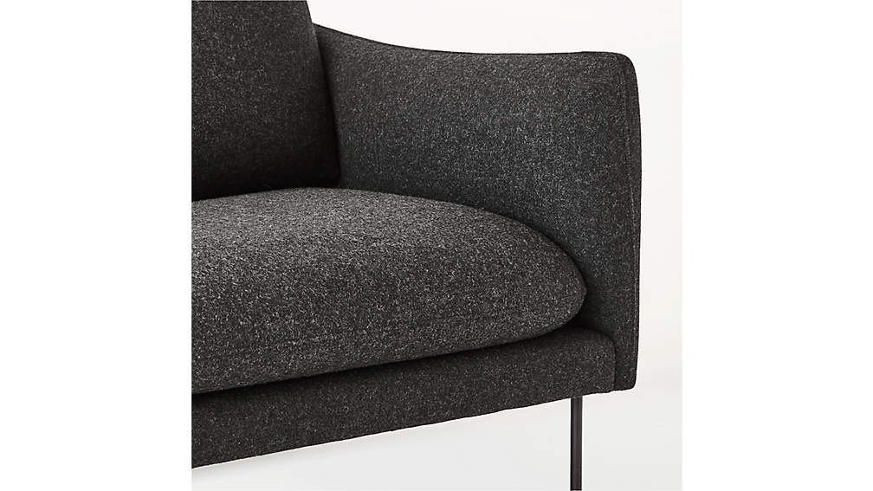

## DIMENSIONS

### DIMENSIONS FOR MAVIS GREY WOOL SOFA

##### **Overall Dimensions**

Width: 87"

Depth: 37"

Height: 31"

##### **Seat Dimesnsions**

Depth: 24.75"

Height: 15"

1. BACIO Sofa TEDDY WHITE:

Boucle takes on camel-colored hues in loungeable sofa designed by Ross Cassidy. Bubbly in shape with rounded legs of solid bleached oak and an oversized silhouette made for spreading out. CB2 exclusive.

DETAILS

* Designed by Ross Cassidy
* Wool/poly boucle upholstery
* Down-wrapped cushions
* FSC ®-certified wood frame
* Solid bleached oak legs
* Spot-clean with water-free cleaning solvent; do not use water
* Vacuum regularly; professional upholstery cleaning recommended
* Imported
* See product label or call customer service for additional details on product content

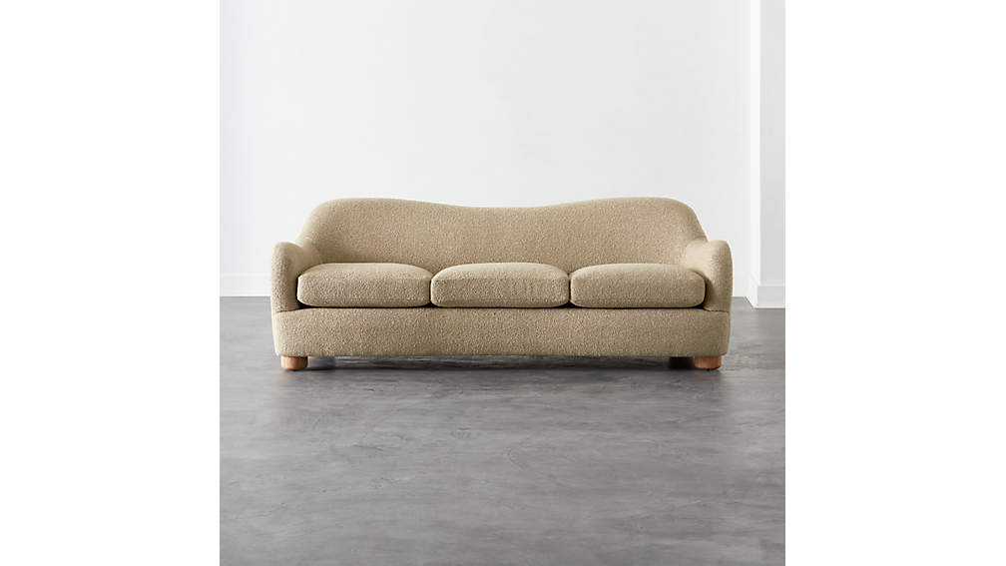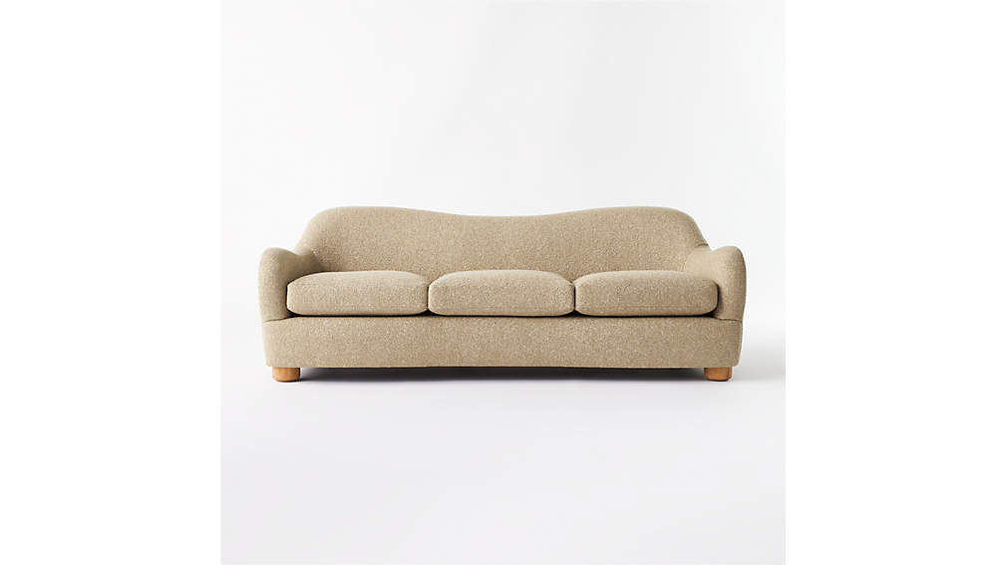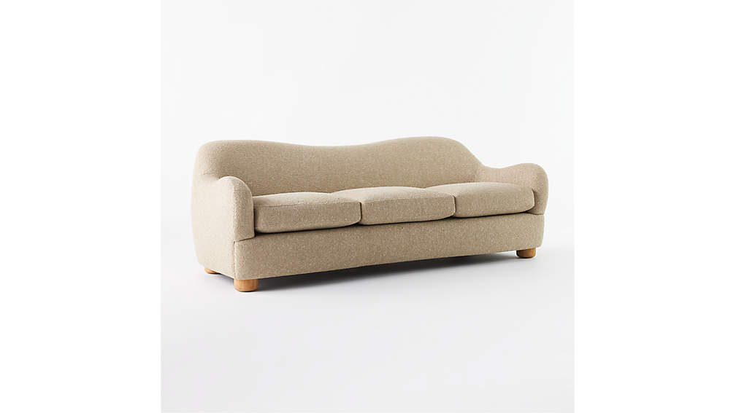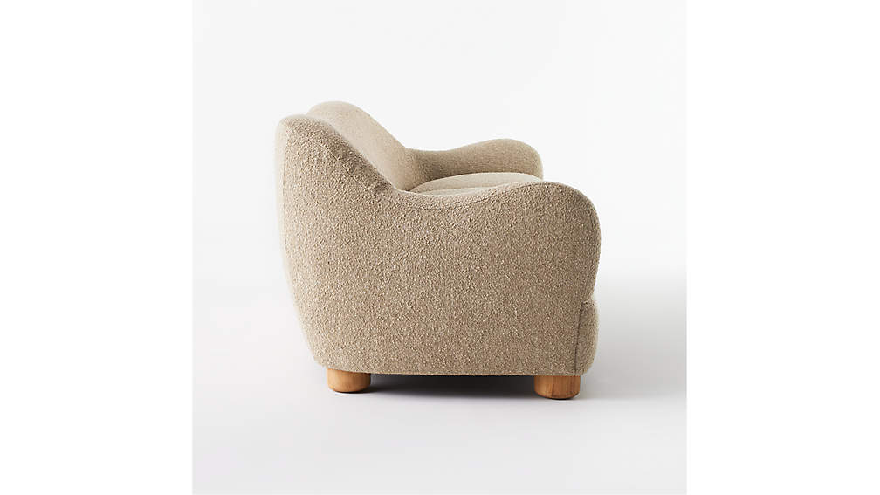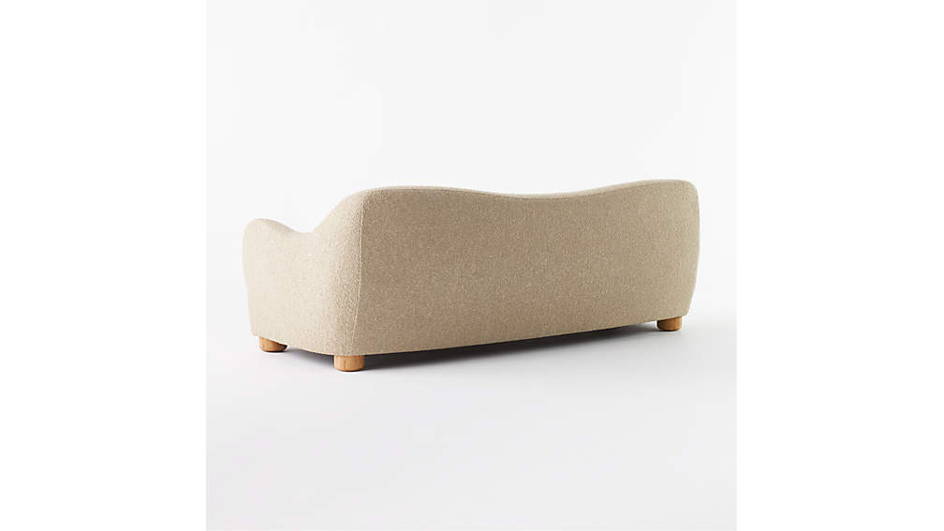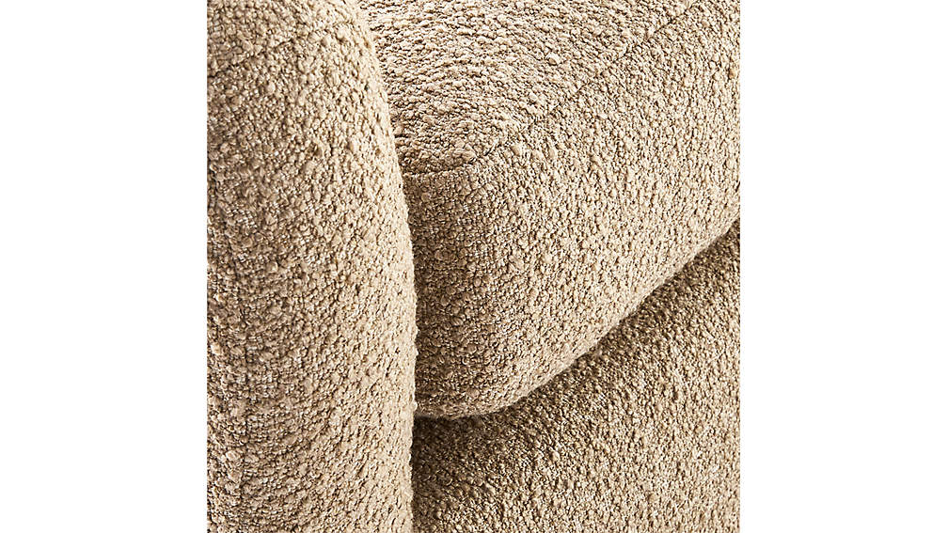

## DIMENSIONS

### DIMENSIONS FORBACIO SOFA

##### **Overall Dimensions**

Width: 86.5"

Depth: 36.5"

Height: 31"

##### **Seat Dimensions**

Width: 75"

Depth: 23"

Height: 17"

1. RYKER WHITE SOFA

Deep seat and low back make for one seriously modern, sleek sofa. Designed by VUUE, white sofa sits sophisticated on stainless steel legs that extend up its arms for a unique and refined design detail. Cozy white Crypton performance velvet lends a bit of midcentury modern inspiration, too. Learn more about [VUUE](https://www.cb2.com/blog/ceci-thompson/) on our blog. CB2 exclusive.

DETAILS

* Designed by VUUE
* 100% polyester Crypton performance velvet in eggshell
* Polished stainless steel legs
* Sinuous wire suspension
* Blot spills immediately
* Keep out of direct sunlight
* Imported
* See product label or call customer service for additional details on product content

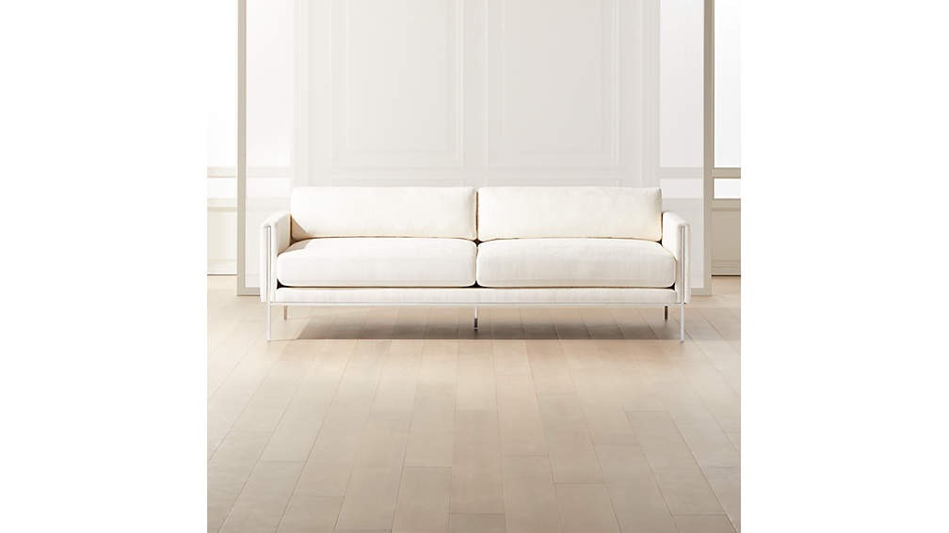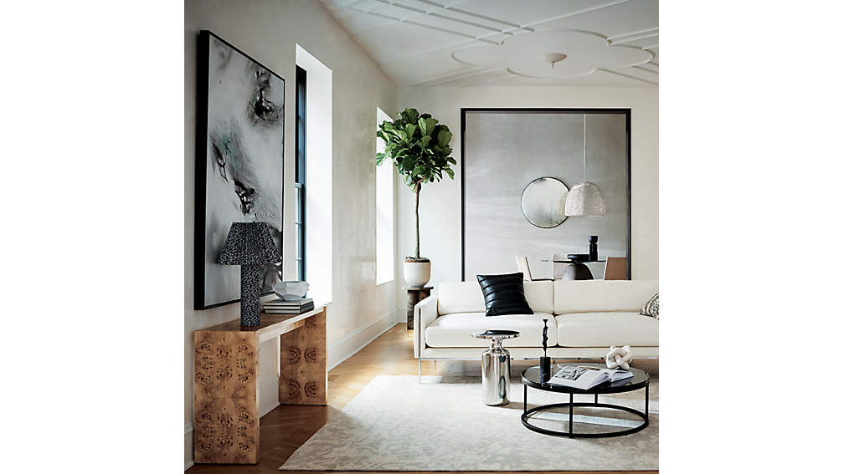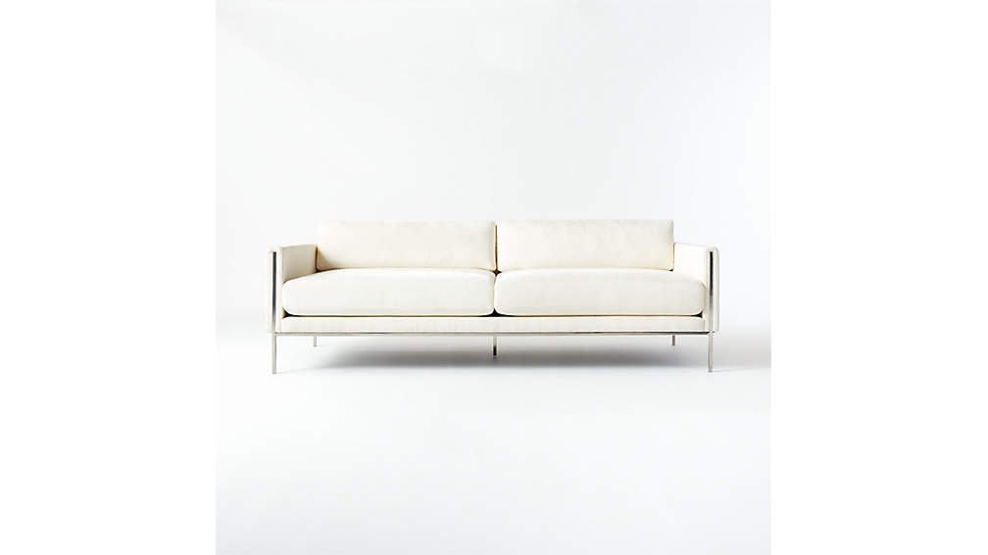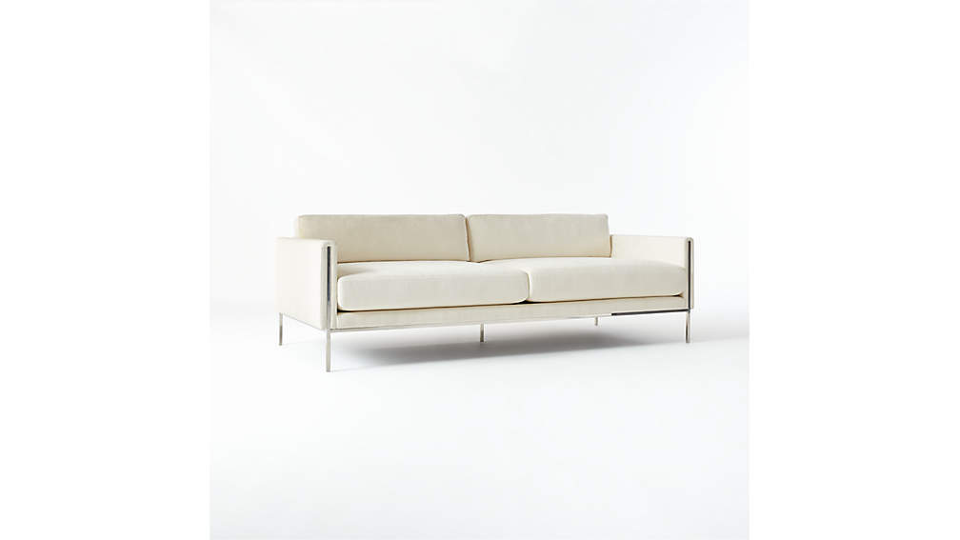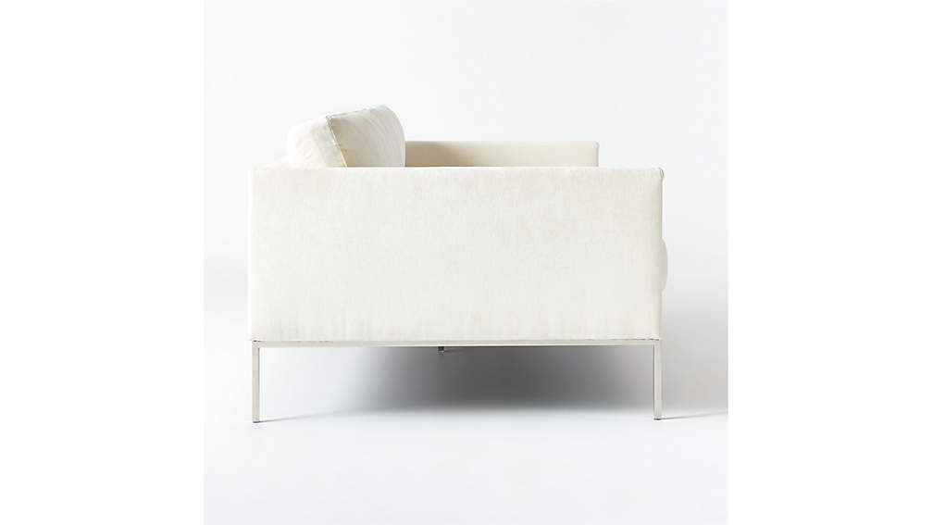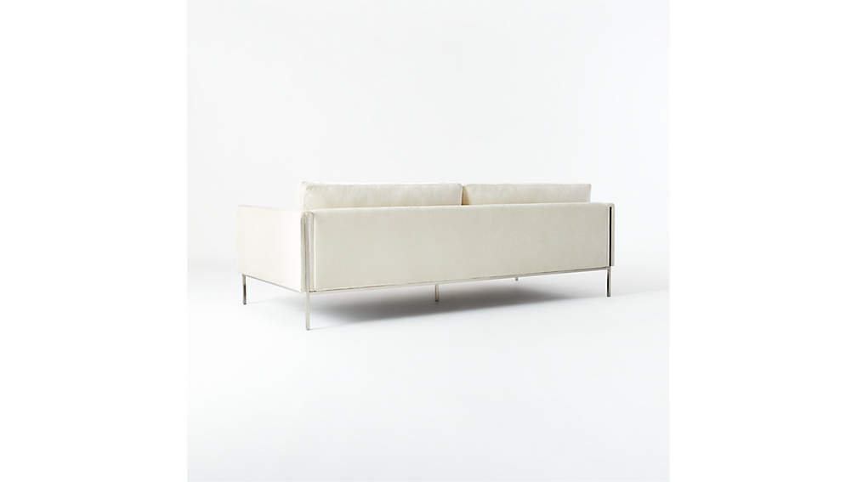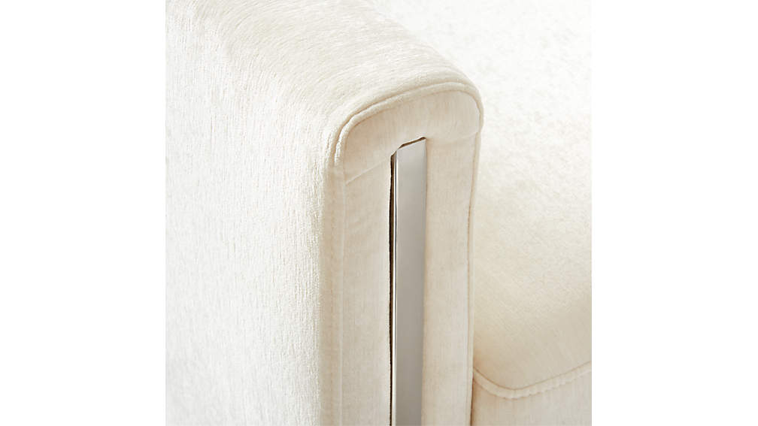

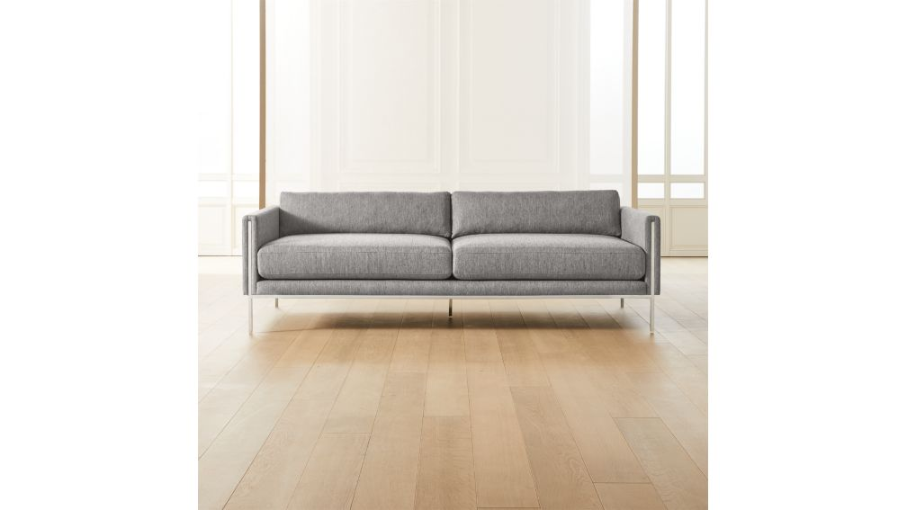

## DIMENSIONS

### DIMENSIONS FORRYKER WHITE SOFA

##### **Overall Dimensions**

Width: 92"

Depth: 42"

Height: 29.25"

##### **Seat Dimensions**

Width: 85"

Depth: 31.25"

Height: 19.5"

##### **Arm Height**

Height: 26"

1. CLAREMONT DARK GREY SOFA:

Tailored sofa in charcoal grey menswear-inspired fabric goes from day to night seamlessly. Remove the back cushions, pull up the seat and extend front legs from hidden zipper pockets underneath. Slide the seat forward and fold the back down. No need to pull away from the wall or unfold a heavy mattress. Neat feature: Full-length arms become the headboard and footboard. Sofa sleeps two comfortably. CB2 exclusive.

DETAILS

* Poly fabric: Dark grey
* Poplar and plywood frame
* Pocket spring/foam mattress
* Queen-size sleeper
* Fits a flat queen sheet
* Keep out of direct sunlight
* Professional upholstery cleaning recommended annually
* See product label or call customer service for additional details on product content

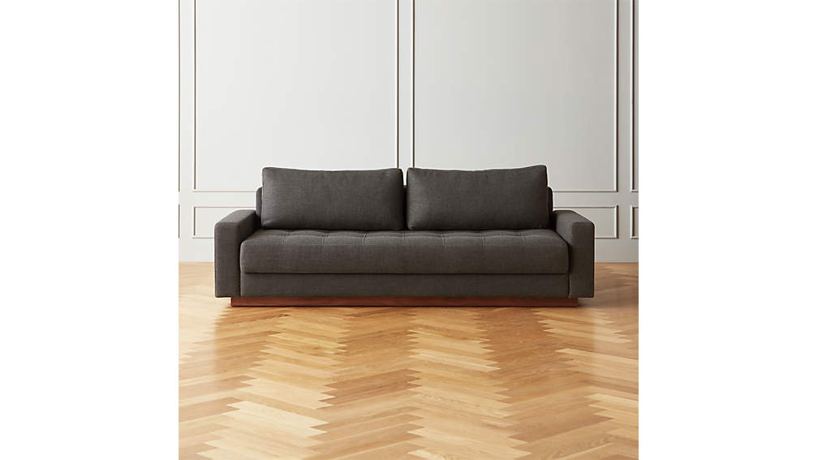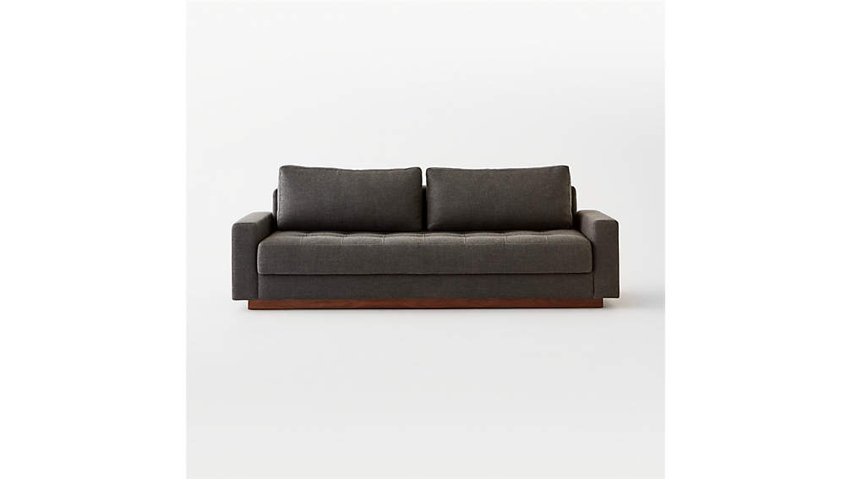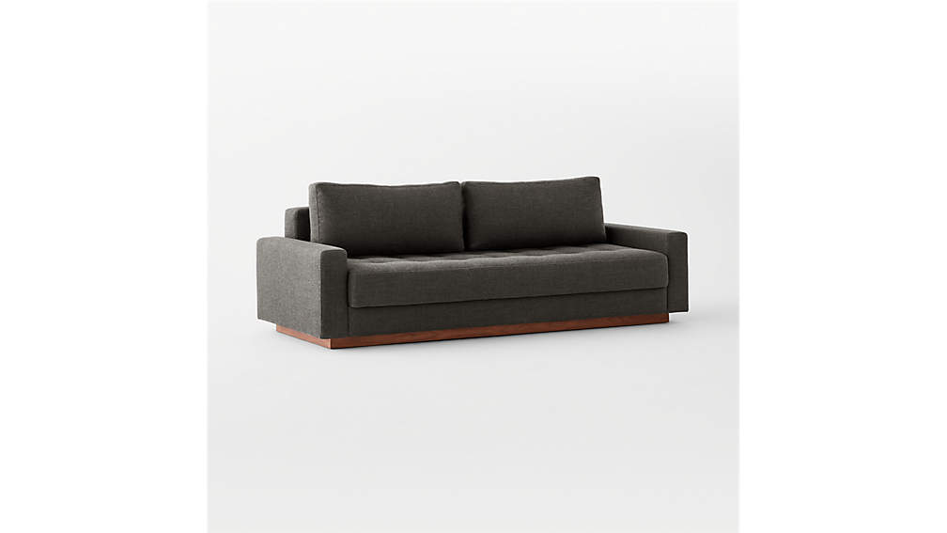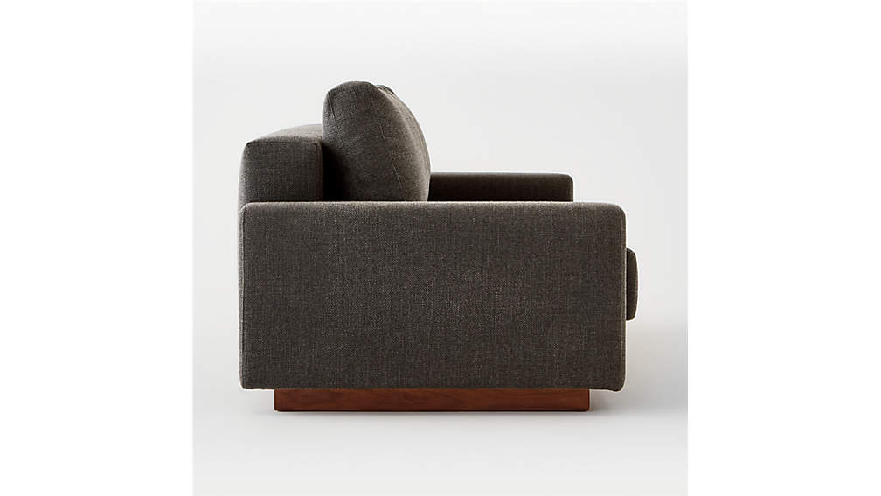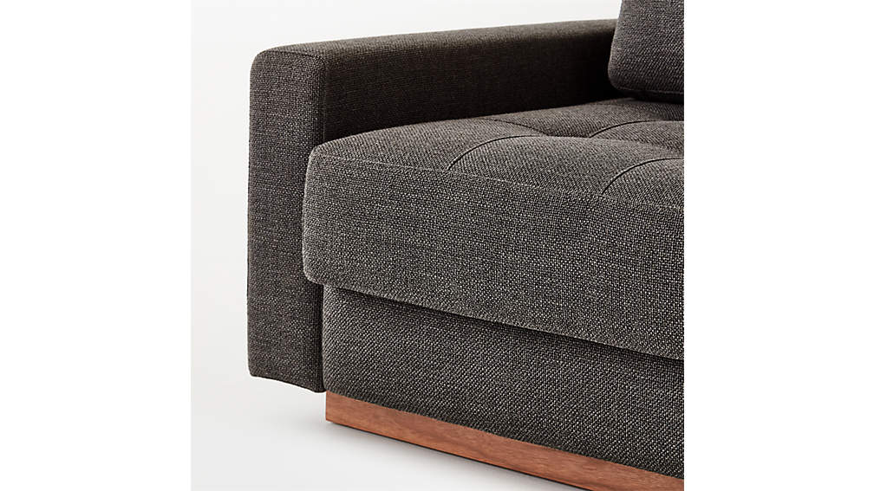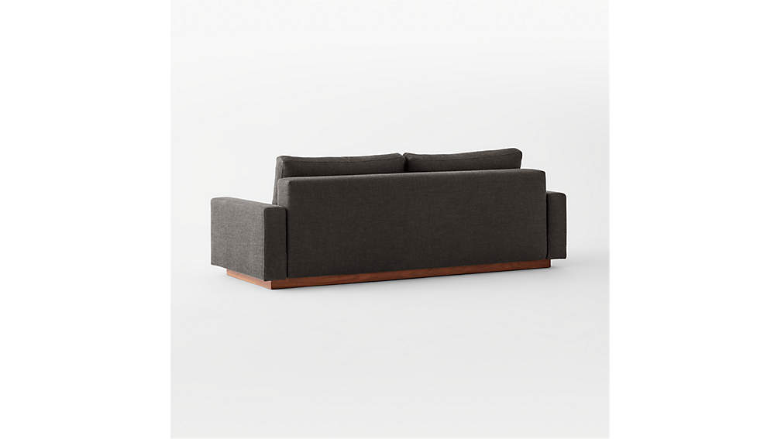

## DIMENSIONS

### DIMENSIONS FORCLAREMONT DARK GREY SLEEPER SOFA

##### **Overall Dimensions**

Width: 87.75"

Depth: 38"

Height: 31.75"

##### **Seat Dimensions**

Width: 75"

Depth: 21"

Height: 20"

1. CAMDEN SOFA:

Mermelada Estudio puts a slightly '70s spin on this vintage-inspired sofa, upholstered in pure white performance fabric for a modern-meets-livable take. Wraparound arms add architectural interest, while three loose back cushions keep it comfortable. Learn about [Mermelada Estudio](https://www.cb2.com/blog/mermelada-estudio/) on our blog. CB2 exclusive.

DETAILS

* Designed by Mermelada Estudio
* Polyester velvet performance fabric
* Performance fabric is water- and stain-resistant and easy to clean
* Feather-down/poly blend back cushions
* Wood frame
* Sinuous wire spring suspension
* Blot spills immediately
* Imported
* See product label or call customer service for additional details on product content

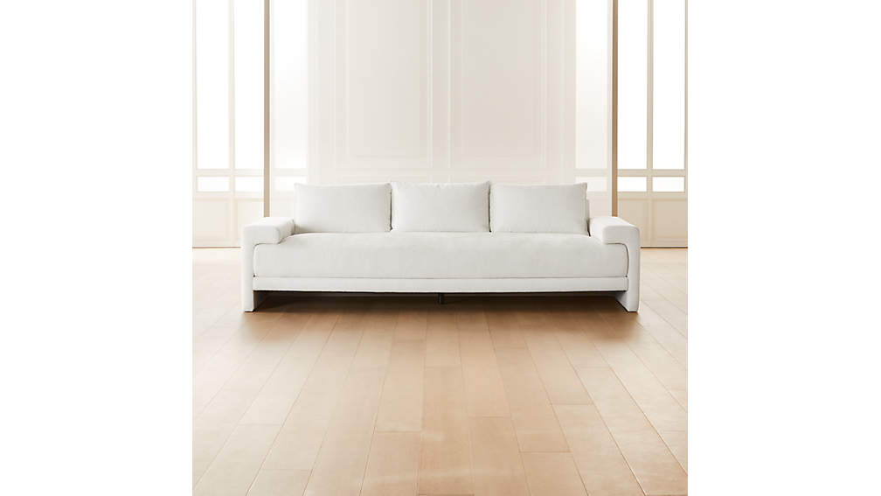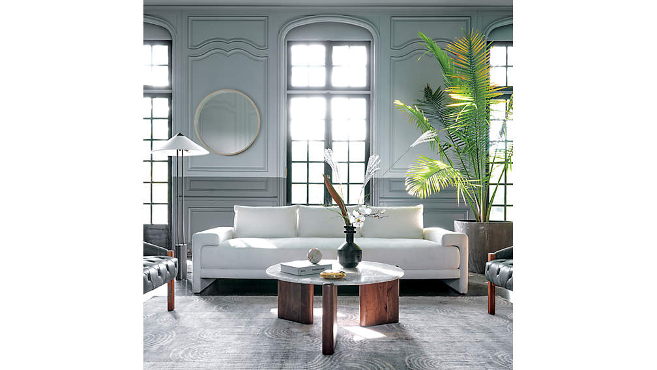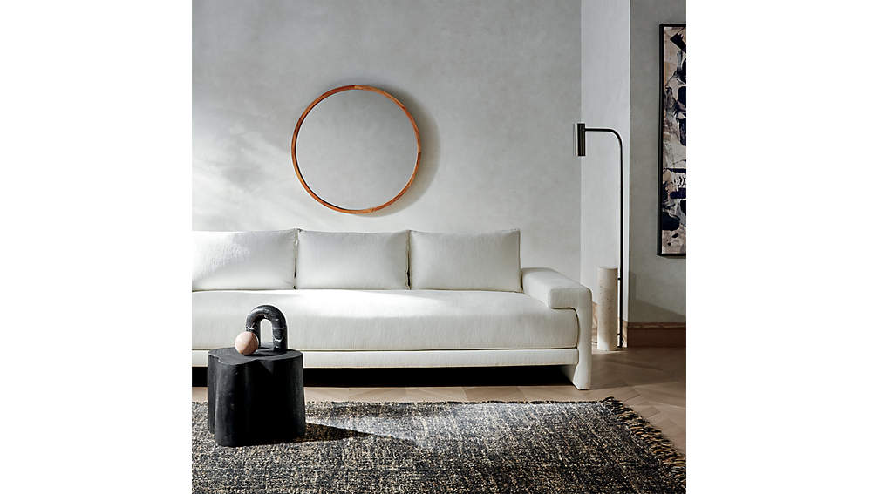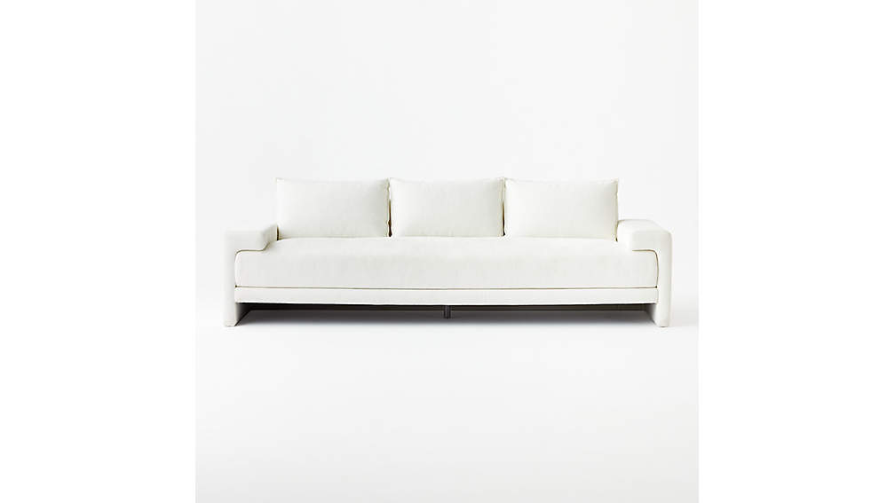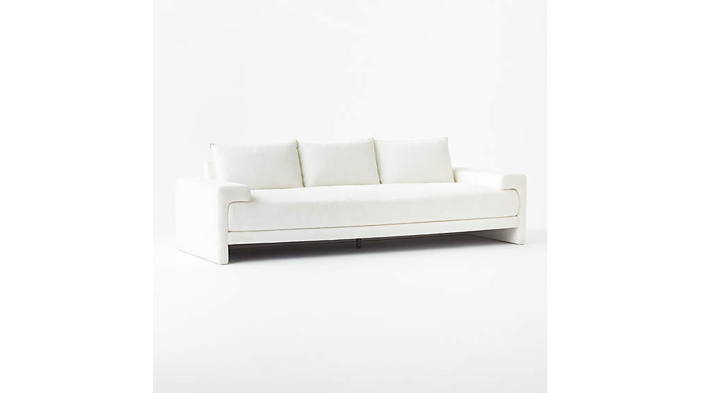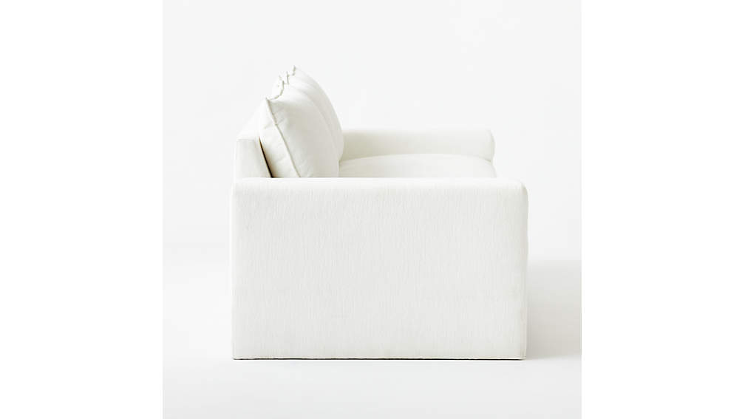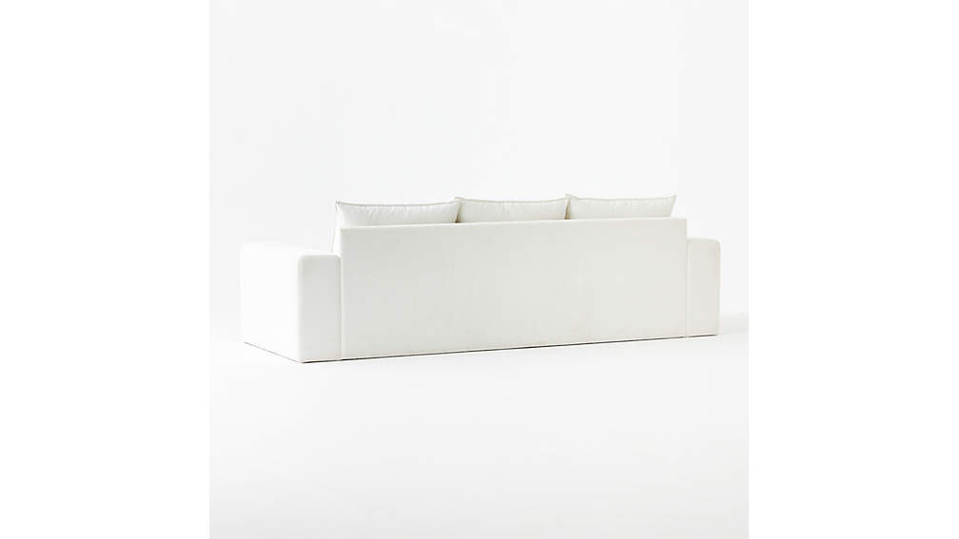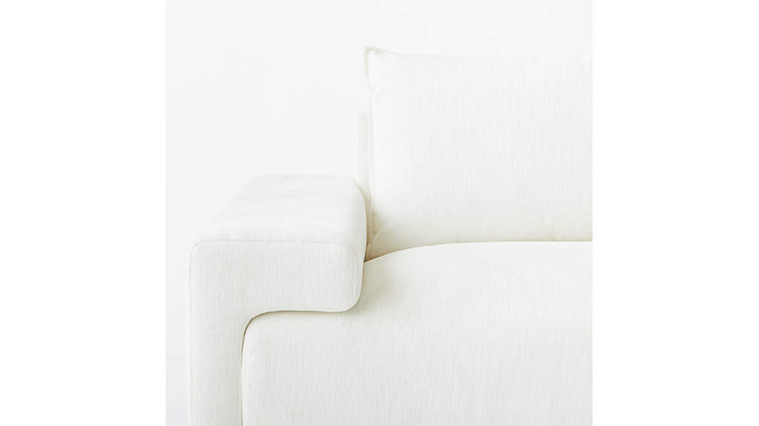

## DIMENSIONS

### DIMENSIONS FORCAMDEN SOFA

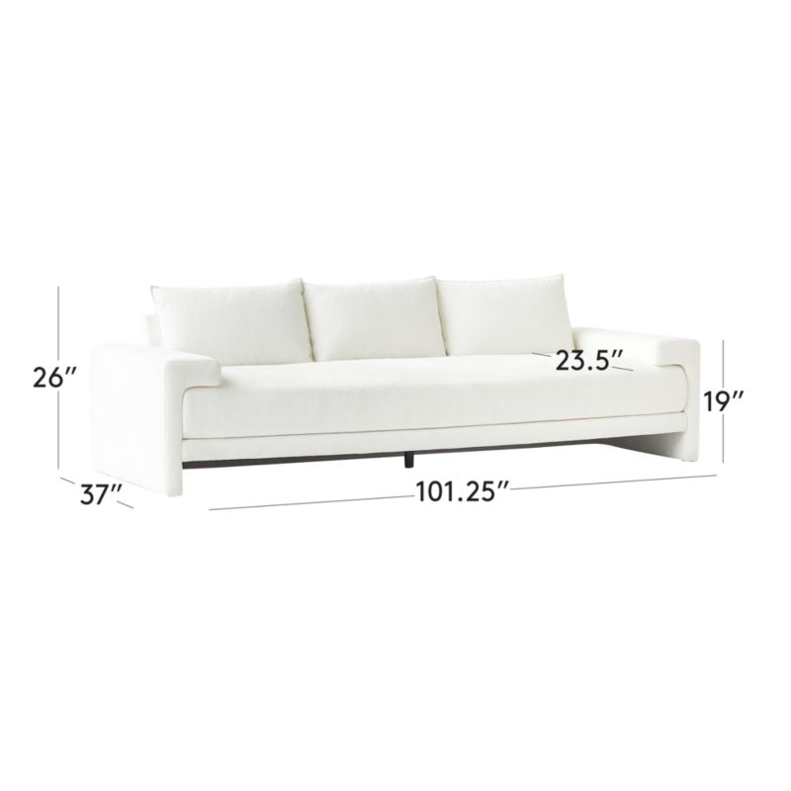

##### **Overall Dimensions**

Width: 101.25"

Depth: 37"

Height: 26"

##### **Leg**

Height: 1.25"

##### **Seat Dimensions**

Width: 80.5"

Depth: 23.5"

Height: 19"

##### **Height With Back Cushion**

Height: 31"

1. HOXTON BLACK LEATHER SOFA

SCALED-UP STYLE. The standard sofa stretches out on a modern frame wrapped in rich black leather. Designed by James Patterson, the sofa's slim, discreet profile is edgy and sleek. Brushed brass finished legs squarely support the generous seat, upholstered in dark leather that will continue to patina with character over time. Learn more about [James Patterson](https://www.cb2.com/blog/james-patterson/) on our blog.

DETAILS

* Designed by James Patterson
* Top grain black buffalo leather
* Hardwood frame
* Brushed brass finished legs
* Sinuous wire suspension
* Each piece will vary due to the natural leather.
* Leather will age and soften over time and natural variations in color and markings.
* Frame constructed with a center support leg
* Clean with soft, dry cloth.
* Keep out of direct sunlight
* Made in Vietnam
* See product label or call customer service for additional details on product content

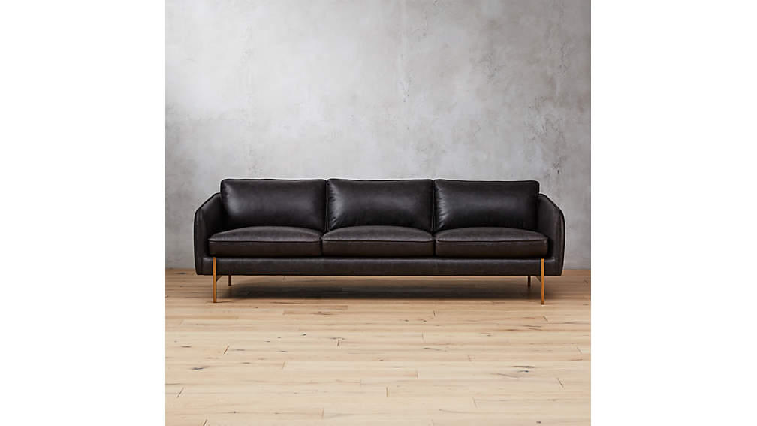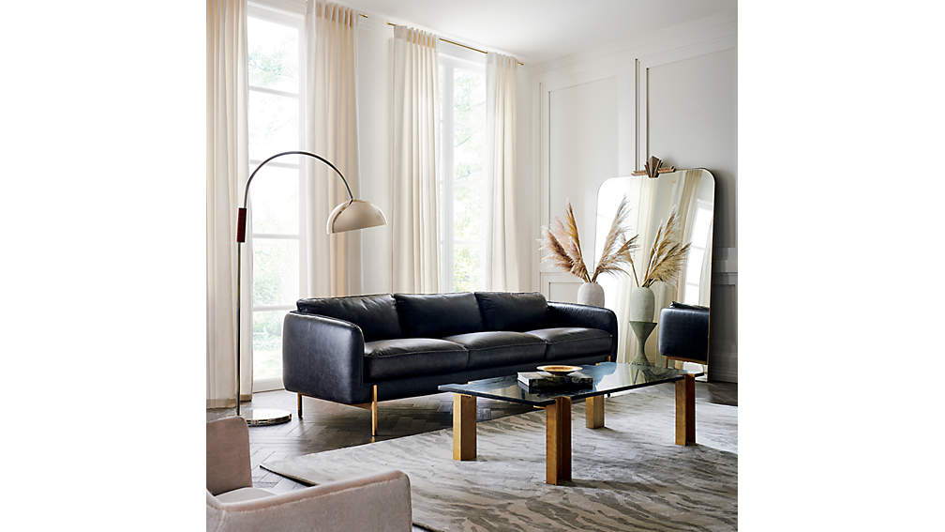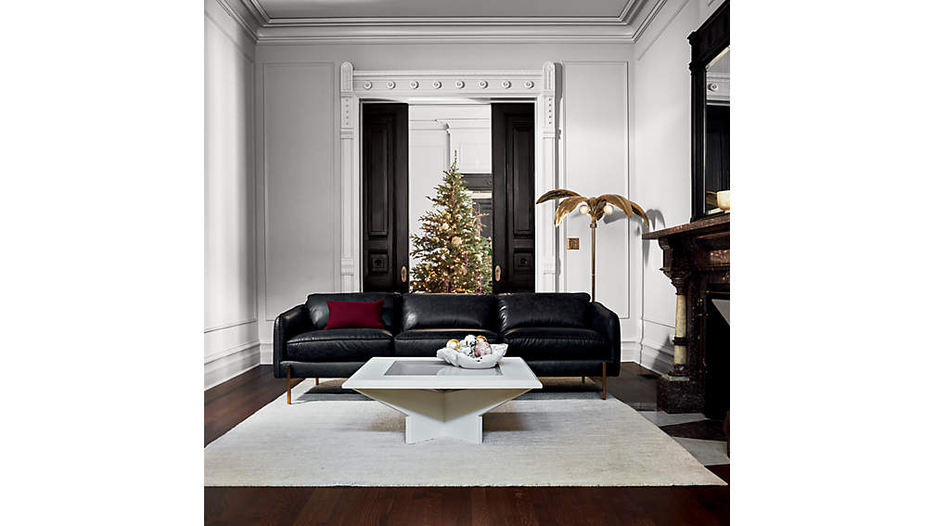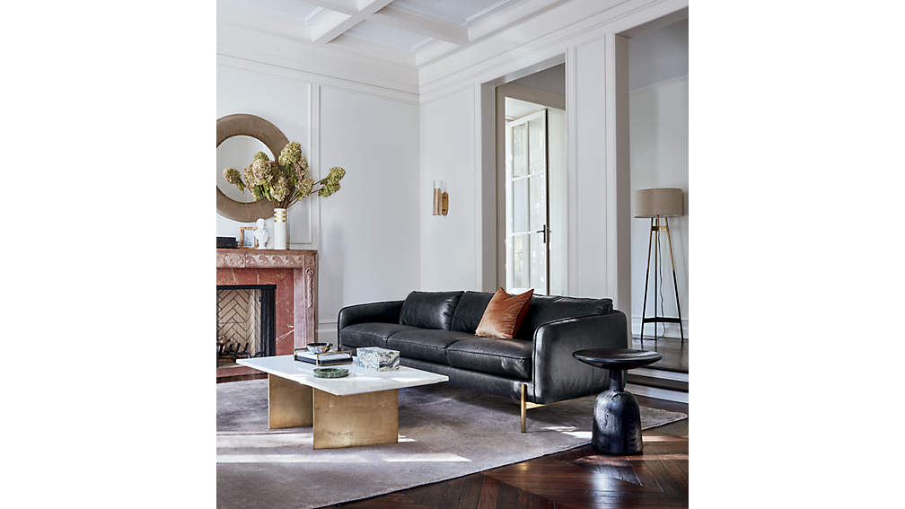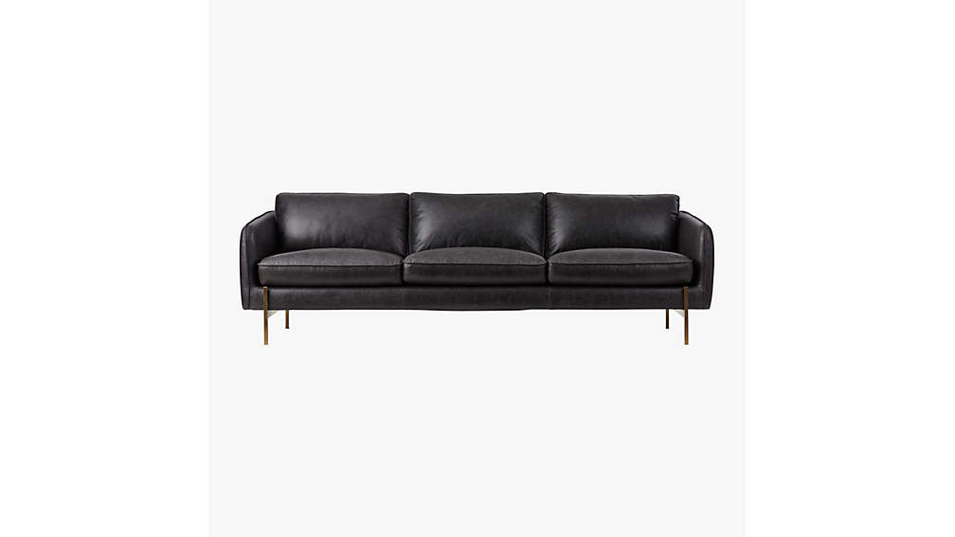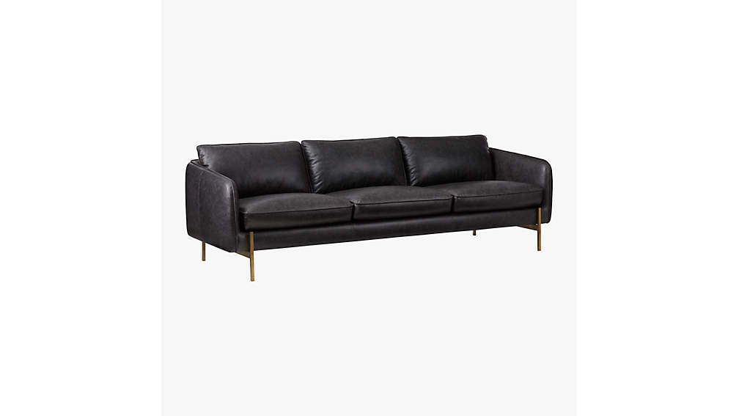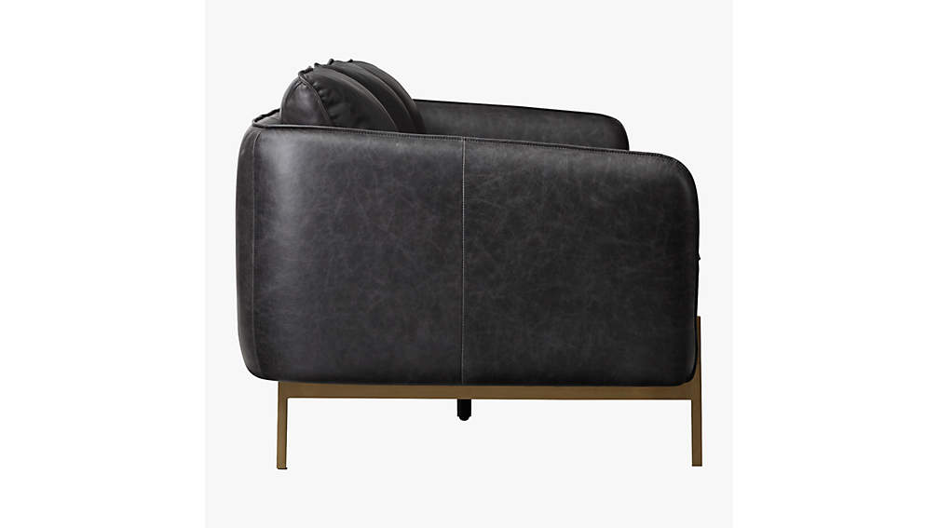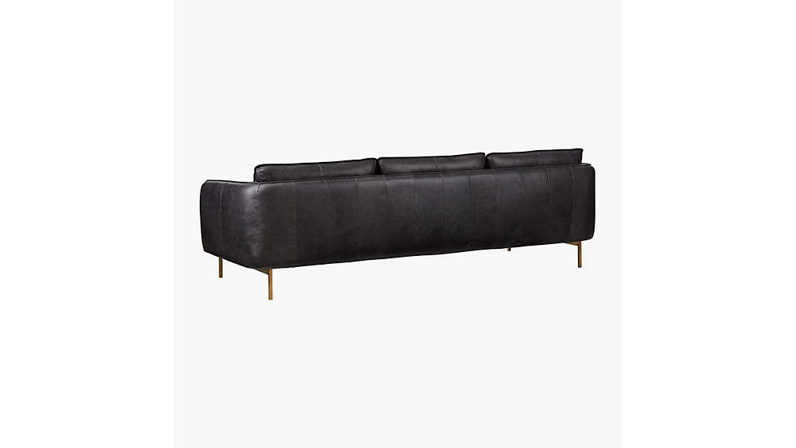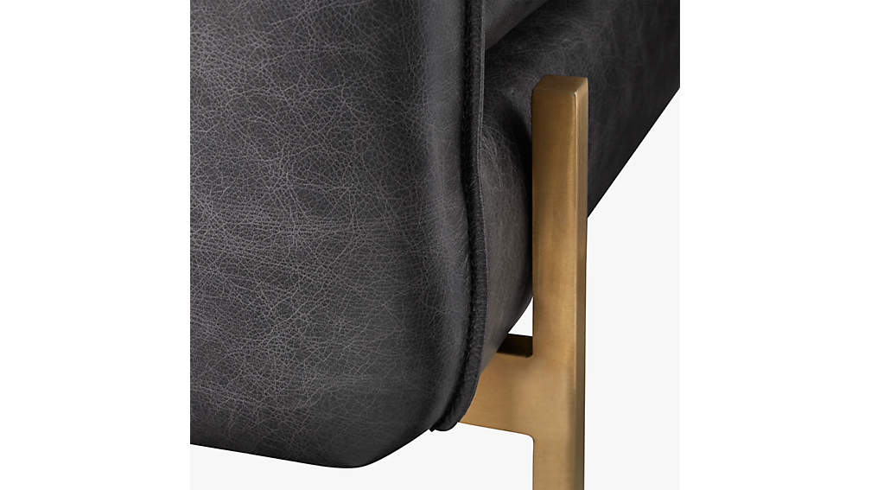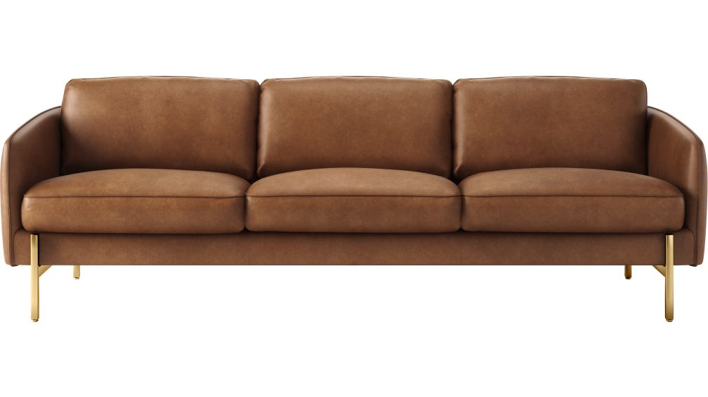

## DIMENSIONS

### DIMENSIONS FORHOXTON BLACK LEATHER SOFA

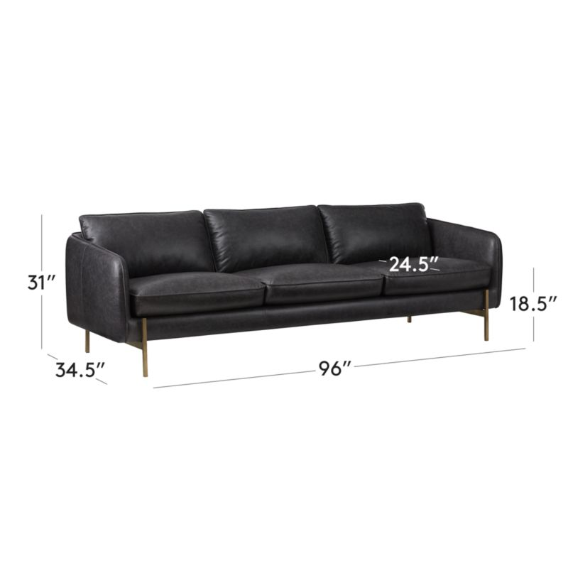

##### **Overall Dimensions**

Width: 96"

Depth: 34.5"

Height: 31"

##### **Seat**

Width: 88"

Depth: 24.5"

Height: 18.5"

##### **Leg Height**

Height: 7.5"

1. HOXTON SOFA:

Sofa scales up on modern upholstered frame made for relaxation. Designed by James Patterson, grey sofa's slim, discreet profile is edgy and sleek. Brushed brass finished legs squarely support the generous seat, upholstered in chic stone fabric. Learn more about [James Patterson](https://www.cb2.com/blog/james-patterson/) on our blog. CB2 exclusive.

DETAILS

* Designed by James Patterson
* Polyester/acrylic upholstery
* Hardwood frame
* Brushed brass finished legs
* Sinuous wire suspension
* Frame constructed with a center support leg
* Clean with soft, dry cloth; blot spills immediately
* Made in Vietnam
* See product label or call customer service for additional details on product content

## 

## DIMENSIONS

### DIMENSIONS FORHOXTON SOFA

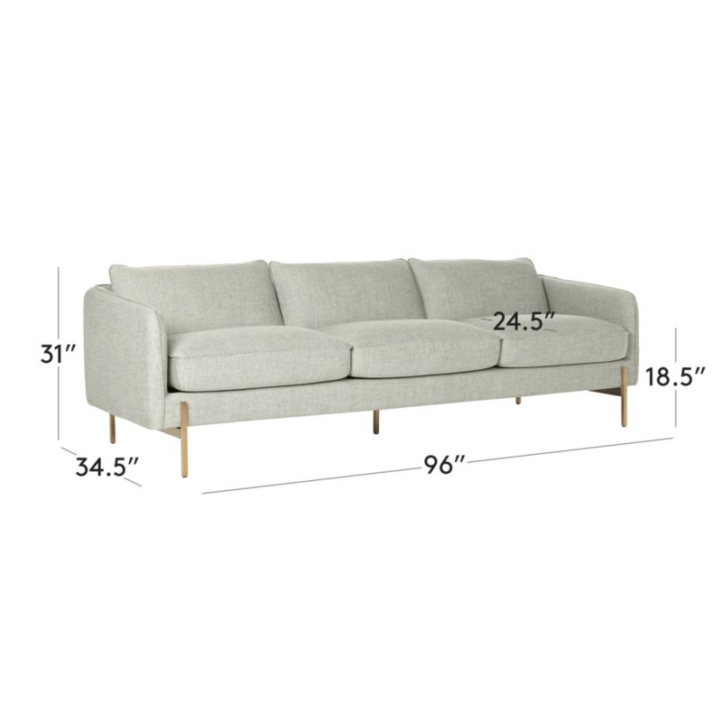

##### **Overall Dimensions**

Width: 96"

Depth: 34.5"

Height: 31"

##### **Seat**

Width: 88"

Depth: 24.5"

Height: 18.5"

##### **Leg Height**

Height: 7.5"

SAVILE TUFTED SOFA:

We edged up the classic Chesterfield sofa with clean modern lines and chic grey upholstery. Out with the traditional curved arms and in with a minimal squared-off frame. Back and sides are fully tufted. Long enough to stretch out for a nap, spacious frame sits on square chrome-plated legs—an ultra-modern detail we couldn't resist. CB2 exclusive.

DETAILS

* Poly/linen fabric: Slate
* Performance fabric is water and stain-resistant and easy to clean
* Detailed with button tufting
* Larch and engineered wood frame
* Removable chrome-plated metal legs with levelers
* Sinuous wire spring suspension
* Seat cushion is high-density foam
* Vacuum regularly
* Keep out of direct sunlight to prevent fading
* Made in Vietnam
* See product label or call customer service for additional details on product content

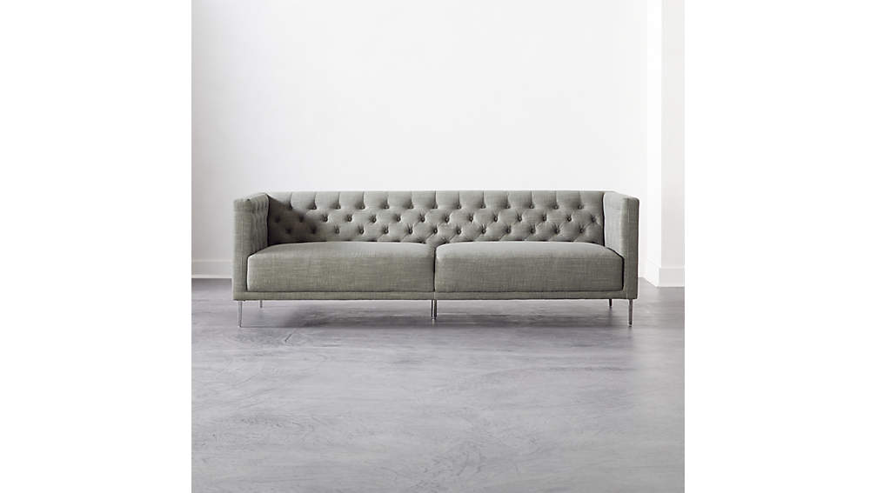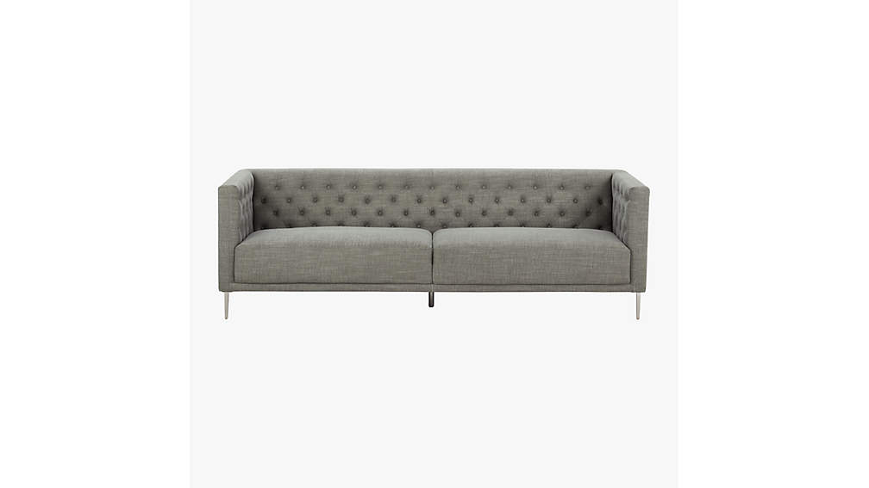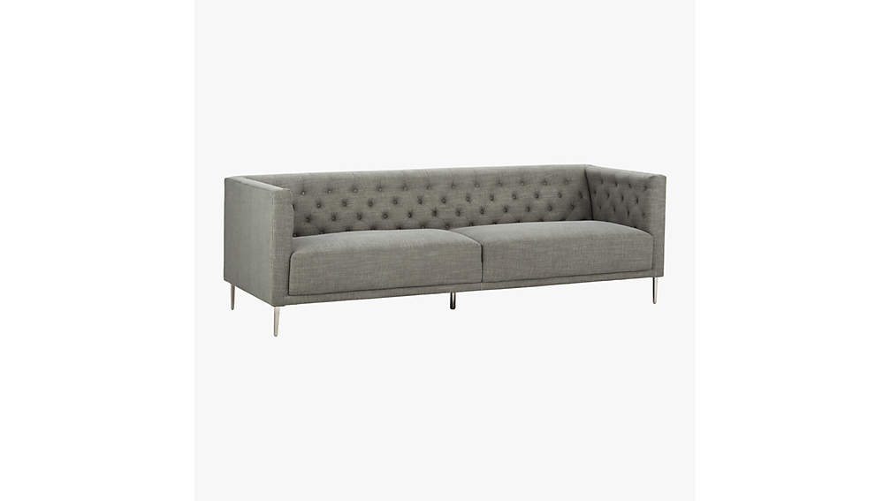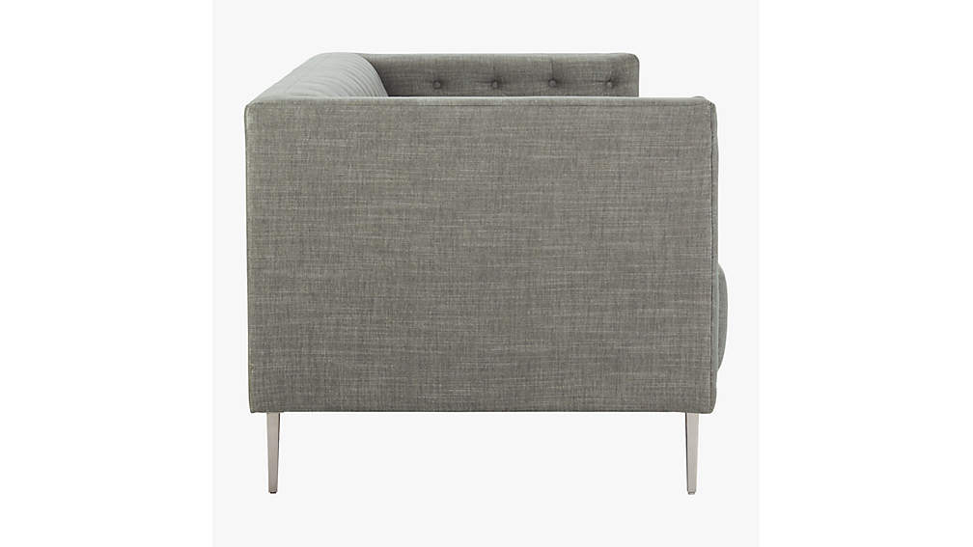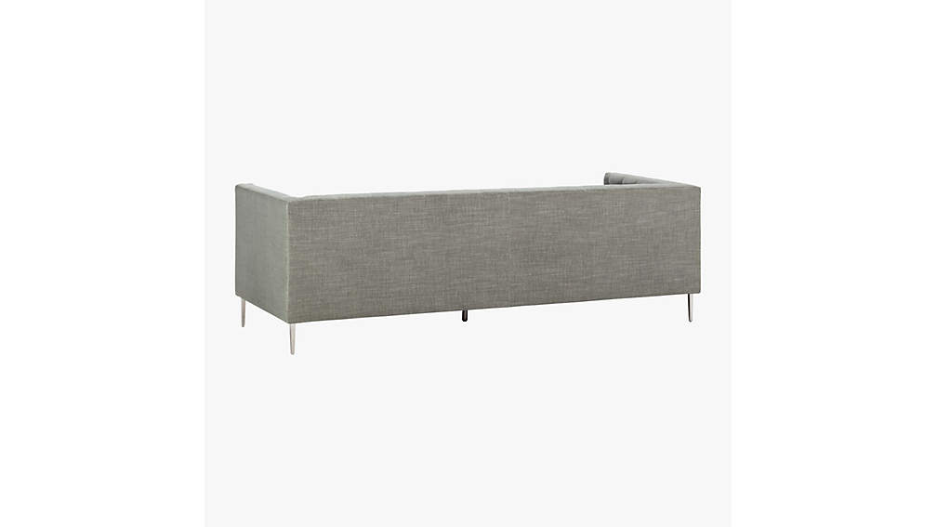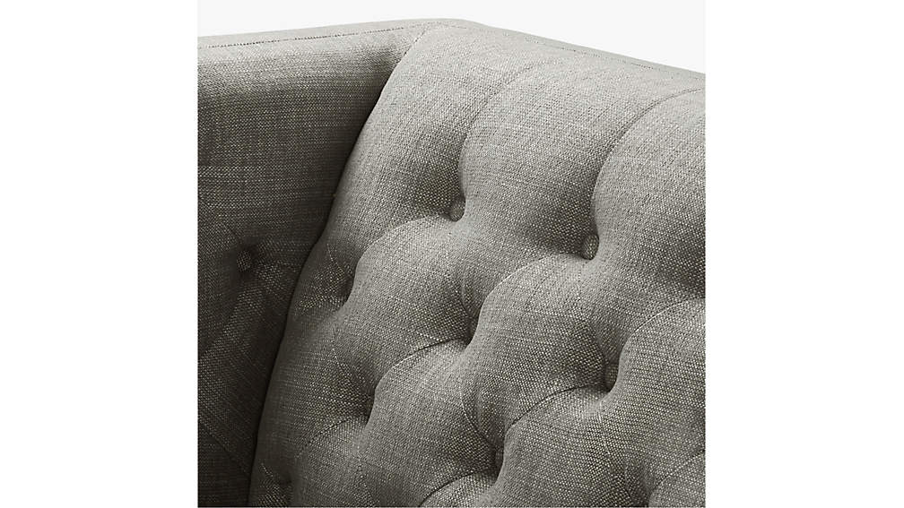

## DIMENSIONS

### DIMENSIONS FORSAVILE TUFTED SOFA

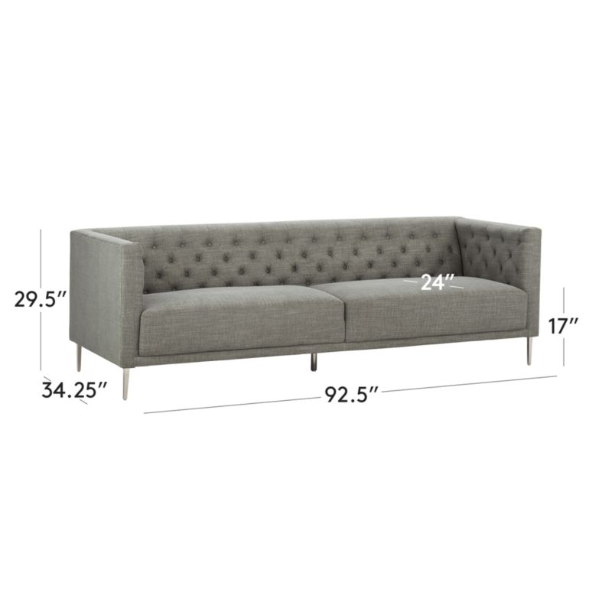

##### **Overall Dimensions**

Width: 92.5"

Depth: 34.25"

Height: 29.5"

##### **Seat**

Width: 84.5"

Depth: 24"

Height: 17"

##### **Arm Width**

Width: 4"

##### **Leg Height**

Height: 6"

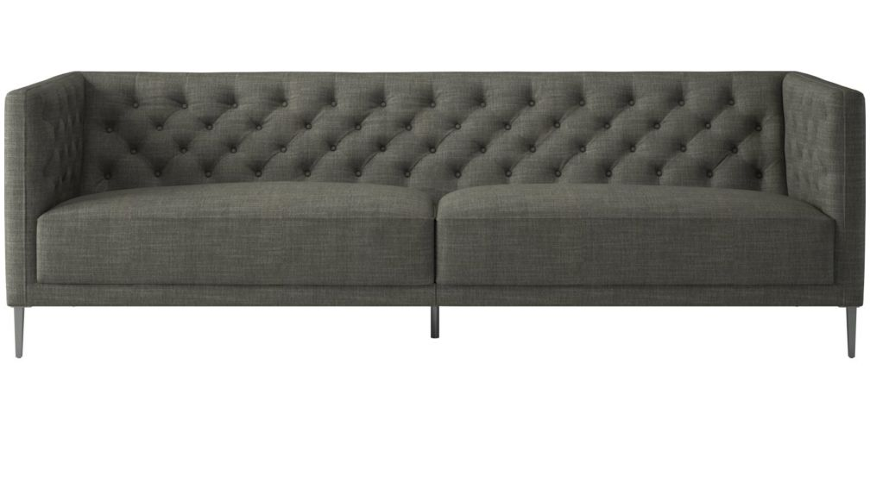

1. TANDOM MICROGRID GREY SOFA

Ingenious sleeper transforms from sofa to guest bed in clever 1-2-3 setup. Modern design sits Euro-deep with oversized back cushions on polished metal tube frame. Goes from upright to lights out via easy one-person operation: off with the back cushions, pull up seat and extend front legs from hidden zipper pockets beneath. Slide seat forward and fold down back. No need to pull away from wall or unfold a heavy mattress. Neat feature: sheltering sides become headboard/footboard.

## DETAILS

* Poly fabric: Microgrid grey
* Metal tube frame
* High-density foam seat cushion/mattress
* Sinuous wire spring suspension
* Easy conversion from sofa to sleeper
* Sleeps two
* Fits a flat queen sheet
* Benchmade
* Imported
* See product label or call customer service for additional details on product content

PRINTTHIS PAGE

EMAILA LINK TO THIS PAGE TO SOMEONE

## DIMENSIONS

### DIMENSIONS FORTANDOM MICROGRID GREY SLEEPER SOFA

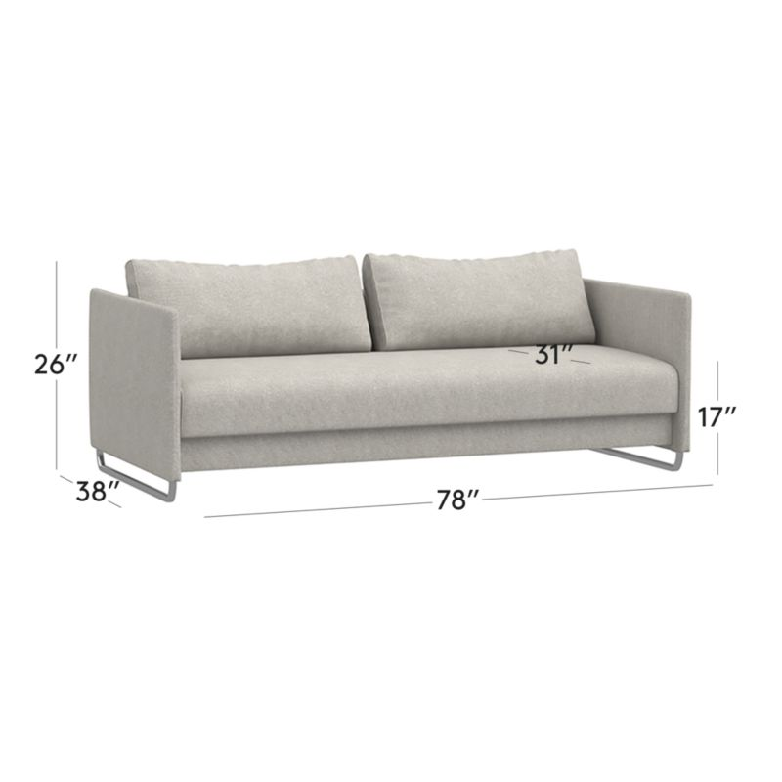

##### **Overall Dimensions**

Width: 78"

Depth: 38"

Height: 26"

##### **Interior Seat**

Width: 75"

Depth: 31"

Height: 17"

##### **Open Dimensions - Sleeper**

Width: 75"

Depth: 56"

Height: 17"

##### **Arm**

Width: 38"

Height: 26"

*Will it fit through   
your door?*

##### **Diagonal**

Width: 87.25"

Depth: 32.75"

